MILESTONE 6: Story
A data story is a way of presenting data and analysis in a narrative format, intending to make the information more engaging and easier to understand. A data story typically includes a clear introduction that sets the stage and explains the context for the data, a body that presents the data and analysis logically and systematically, and a conclusion that summarizes the key findings and highlights their implications. Data stories can be told using a variety of mediums, such as reports, presentations, interactive visualizations, and videos.

No of Scenes of Story
The number of scenes in a storyboard for a data visualization analysis of the performance and efficiency of Product Placement will depend on the complexity of the analysis and the specific insights that are trying to be conveyed. A storyboard is a visual representation of the data analysis process and it breaks down the analysis into a series of steps or scenes.
Explanation Video Link:
https://drive.google.com/file/d/15Q105EwhPRdJiEuYl6q9I7lxqZk8HYWo/view?usp=drive_link

STORY SCENE-1
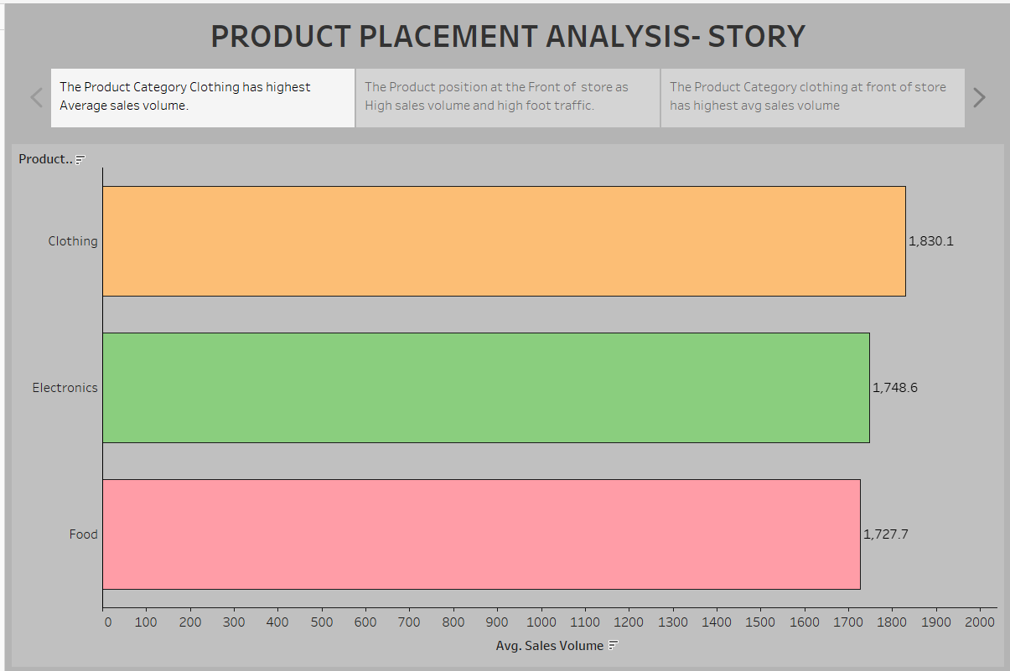
STORY SCENE-2
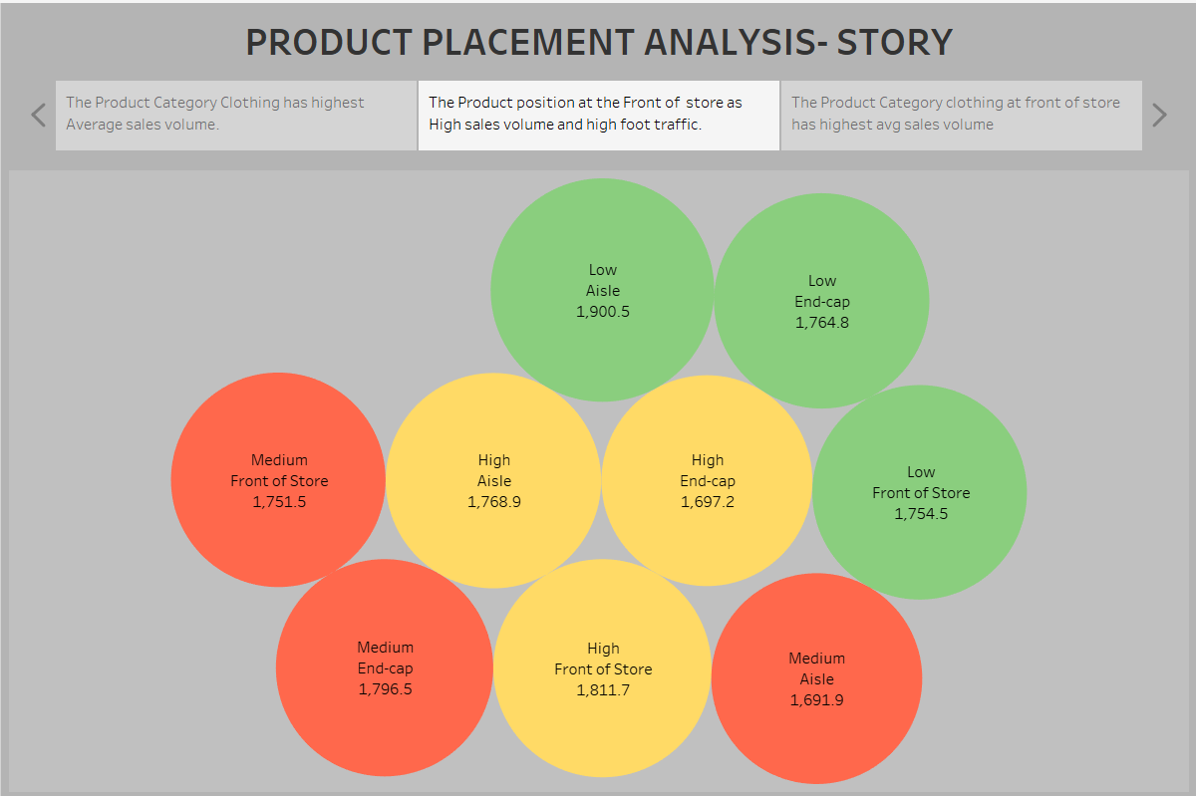

STORY SCENE-3
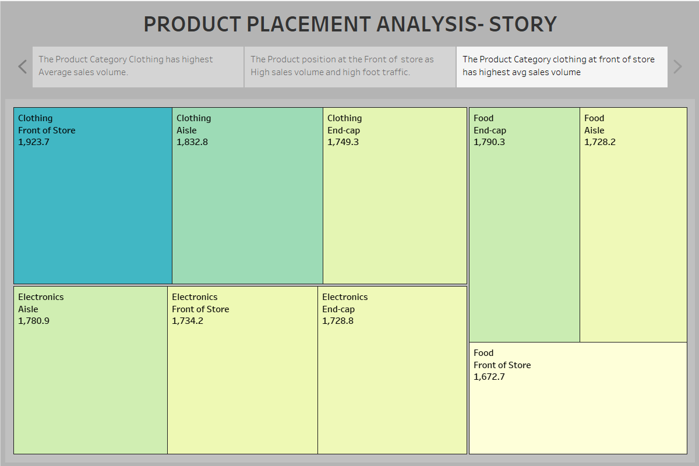

and visualization, allowing users to refine and focus on specific subsets of data
that are relevant to their analysis objectives.

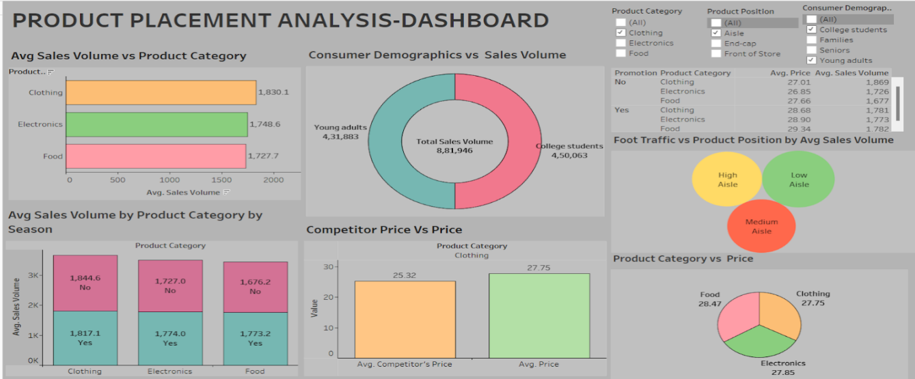

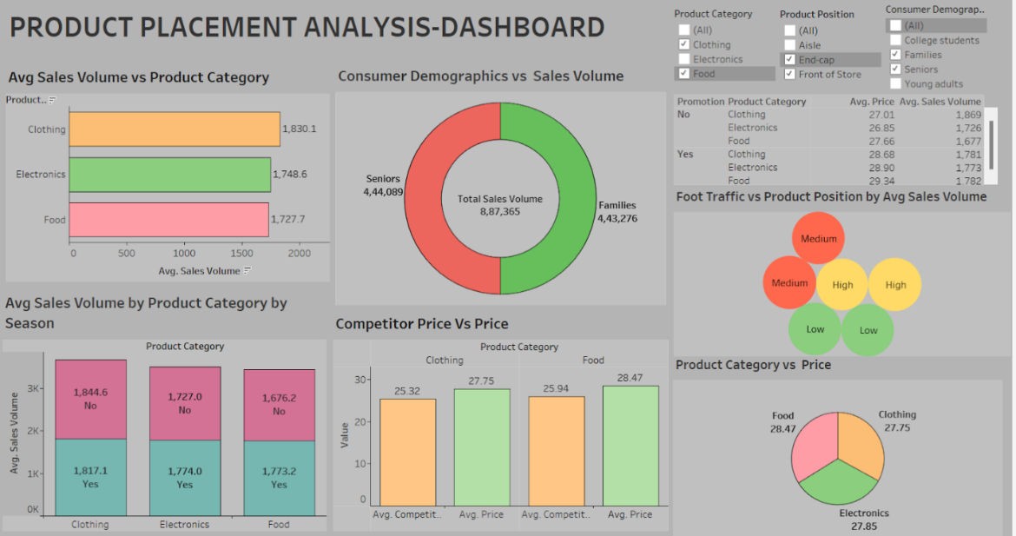

No of Calculation Fields
- Price
- Competitors Price
- Sales Volume
No of Visualizations/ Graphs
? Avg Sales Volume by Product Category
? Avg Sales Volume by Product Category on Sales
? Consumer Demographics vs Product Category
? Foot traffic vs Sales Volume
? Competitors Price vs Price.
? Promotion of Product Category on Price and Sales Volume.
? Product Category vs Price
? Avg Sales Volume by Product Category by Product Position.

